Basic concepts

**1. What is normalization in a DBMS?**

* **Answer:** Normalization is the process of organizing data in a database to reduce data redundancy and improve data integrity. It involves decomposing a large, unorganized table into smaller, well-structured tables and defining relationships between them.

**2. What problems does normalization address?**

* **Answer:** Normalization aims to eliminate data anomalies that occur in an unnormalized database:
  + **Insertion Anomaly:** Inability to add a new record without including related, and potentially unavailable, data.
  + **Deletion Anomaly:** Accidental loss of critical data when a record is deleted.
  + **Update Anomaly:** The need to update the same information in multiple places, which can lead to inconsistencies.

**3. What are functional dependencies?**

* **Answer:** A functional dependency (FD) is a constraint between two sets of attributes in a relation. It is represented as



X→Y cap X right arrow cap Y

𝑋→𝑌, where X cap X

𝑋

is the determinant and Y cap Y

𝑌

is the dependent attribute. It means that the value of X cap X

𝑋

uniquely determines the value of Y cap Y

𝑌. FDs are fundamental to the normalization process.

Normal forms (1NF to BCNF)

**4. What is the First Normal Form (1NF)?**

* **Answer:** A table is in 1NF if it satisfies these conditions:
  + Each cell contains only an atomic (single-valued) value.
  + There are no repeating groups of columns.
  + Each column has a unique name.

**5. What is the Second Normal Form (2NF)?**

* **Answer:** A table is in 2NF if it is in 1NF and non-key attributes are fully dependent on the primary key, eliminating partial dependencies.

**6. What is the Third Normal Form (3NF)?**

* **Answer:** A table is in 3NF if it is in 2NF and has no transitive dependencies, where a non-key attribute depends on another non-key attribute instead of the primary key.

**7. How can you tell if a table is in 3NF?**

* **Answer:** According to William Kent's maxim, in 3NF, "a non-key field must provide a fact about the key, the whole key, and nothing but the key".

**8. What is Boyce-Codd Normal Form (BCNF)?**

* **Answer:** BCNF is a stricter form of 3NF where for every non-trivial functional dependency

X→ Y cap X right arrow cap Y

𝑋→𝑌, X cap X

𝑋, must be a super key. It handles certain anomalies 3NF might miss, particularly with multiple overlapping candidate keys.

**9. Explain the difference between 3NF and BCNF.**

* **Answer:** BCNF is more stringent than 3NF. While 3NF allows a non-key attribute to be determined by another non-key attribute not part of the primary key, BCNF requires the determinant of *every* functional dependency to be a super key, addressing potential anomalies in 3NF tables with multiple candidate keys.

Advanced and practical questions

**10. What is denormalization, and when is it useful?**

* **Answer:** Denormalization intentionally adds redundant data to improve performance for read-heavy applications like data warehousing and reporting by reducing complex joins.

**11. Provide an example of how to normalize a simple table.**

* **Answer:** Normalizing an employee table with transitive dependencies on state code and job code would involve decomposing it into Employee (employee, name, job code, state code), Job (job code, job), and State (state code, home state) tables to ensure attributes depend directly on their keys.

**12. Can a table be in BCNF but not preserve all functional dependencies?**

* **Answer:** Yes, achieving BCNF can sometimes result in the loss of certain functional dependencies, particularly when dependencies involve attributes from different candidate keys separated during decomposition.

**13. What is the highest normal form typically used, and why might you stop before achieving higher normal forms?**

* **Answer:** 3NF is often sufficient for business applications. Higher forms like BCNF, 4NF, or 5NF can increase the number of tables, potentially degrading performance due to increased join operations. The choice depends on balancing data integrity and performance needs.

AI responses may include mistakessThank you

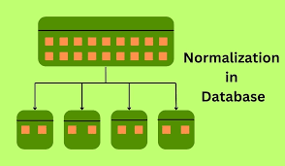Your feedback helps Google improve. See our [Privacy Policy](https://policies.google.com/privacy?hl=en).

Share more feedbackReport a problemClose

* Types of Functional Dependencies in DBMS + 4 Examples

26 Jul 2024 — Types of Functional Dependencies in DBMS + 4 Examples. ... Functional dependencies are a fundamental concept in data...

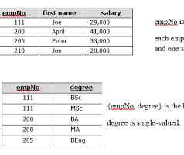

Monday.com

Show all





undefined

20 sites

* 



undefined

20 sites

* Normal Forms 1nf 2nf 3nf Table Examples - freeCodeCamp

20 Dec 2022 — What is 1NF 2NF and 3NF? 1NF, 2NF, and 3NF are the first three types of database normalization. They stand for first...



freeCodeCamp

* Normal Forms 1nf 2nf 3nf Table Examples - freeCodeCamp

20 Dec 2022 — So all the concepts in 1NF also carry over to 2NF, and so on. * The First Normal Form – 1NF. For a table to be in th...



freeCodeCamp

* Normalization in DBMS: 1NF, 2NF, 3NF and ... - Naukri.com

22 Mar 2025 — What is Normalization in DBMS? * Normalization is the process of organizing database data by minimizing redundancy a...



Naukri.com



* Third Normal Form (3NF) - GeeksforGeeks

24 Jul 2025 — Third Normal Form (3NF) ... The Third Normal Form (3NF) builds on the First (1NF) and Second (2NF) Normal Forms. Ach...

favicon

GeeksforGeeks

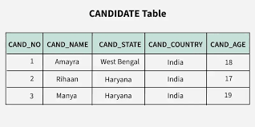

* First Normal Form (1NF) - GeeksforGeeks

8 Sept 2025 — First Normal Form (1NF) ... First Normal Form (1NF) ensures that the structure of a database table is organized in a...

favicon

GeeksforGeeks



* Boyce-Codd Normal Form (BCNF) - GeeksforGeeks

24 Jul 2025 — Boyce-Codd Normal Form (BCNF) * Boyce-Codd Normal Form (BCNF) is an advanced version of 3NF used to reduce redundanc...

favicon

GeeksforGeeks

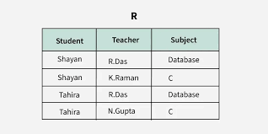

* Second Normal Form (2NF) - GeeksforGeeks

11 Jul 2025 — Second Normal Form (2NF) ... Second Normal Form (2NF) is based on the concept of fully functional dependency. It is ...

favicon

GeeksforGeeks

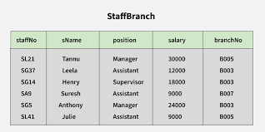

* Boyce-Codd Normal Form (BCNF) - Kev's Robots

Understanding Boyce-Codd Normal Form (BCNF) and its role in advanced database normalization. ... In this lesson, we'll explore Boy...



Kev's Robots



* Normal Forms in DBMS - GeeksforGeeks

19 Sept 2025 — Normal Forms in DBMS * Normal forms are a set of progressive rules (or design checkpoints) for relational schemas t...

favicon

GeeksforGeeks

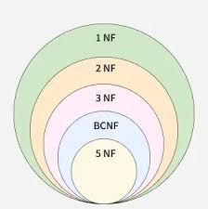

* SQL Interview Questions CHEAT SHEET (2025) - InterviewBit

22 Dec 2024 — What is Denormalization? Denormalization is the inverse process of normalization, where the normalized schema is con...

favicon

InterviewBit

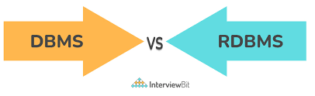

* Normalization Questions With Answers - mcsprogram

* 1. What is First Normal Form (1NF)? * 2. What is Second Normal Form (2NF)? * 3. What is Third Normal Form (3NF)? * 4. What is Bo...



mcsprogram

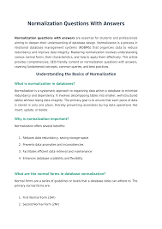

* Third normal form - Wikipedia

In other words, each non-prime attribute must depend solely and non-transitively on each candidate key. William Kent summarised 3N...



Wikipedia

* Boyce Codd Normal Form (BCNF) in DBMS

Boyce Codd Normal Form (BCNF) in DBMS. ... What is BCNF and its role in database design? It's a level of database normalisation us...

favicon

The Knowledge Academy

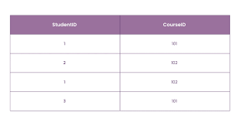

* Types of Functional Dependencies in DBMS + 4 Examples

26 Jul 2024 — Types of Functional Dependencies in DBMS + 4 Examples. ... Functional dependencies are a fundamental concept in data...



Monday.com



* Second Normal Form in DBMS - BYJU'S

29 Dec 2021 — * What is the Second Normal Form in DBMS? In simpler words, a relation is said to be in 2NF when it exists in 1NF, w...

favicon

BYJU'S

* Types of Functional dependencies in DBMS - GeeksforGeeks

22 Jul 2025 — Types of Functional dependencies in DBMS * In relational database management, functional dependency is a concept tha...

favicon

GeeksforGeeks

* Understanding Boyce-Codd Normal Form (BCNF) | by Amirnagy

18 Jun 2025 — Deletion Anomaly: If we delete Ali's last course, we lose the data about the room he teaches in. * ✅ The BCNF Soluti...



Medium



* Functional Dependencies And Normalization For Relational ...

Key Concepts in Functional Dependencies. Determinant: The attribute or set of attributes on the left side of the FD (e.g., Employe...



mcsprogram

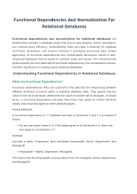

* Understanding First Normal Form (1NF) in DBMS | by Amirnagy

8 Jun 2025 — 📘 Understanding First Normal Form (1NF) in DBMS. ... In the previous article, we explored the concept of Normalizati...



Medium



* Normalization Questions And Answers - narpm

Q4: How do you normalize a database table step-by-step? Ensure 1NF: Make sure all columns contain atomic values. 1. Apply 2NF: Rem...

National Association of Residential Property Managers (NARPM®)

* DBMS – Normalization Interview Questions - Scribd

DBMS – Normalization Interview Questions * 1. What is database normalization, and why is it important in database design? * 2. Exp...

favicon

Scribd

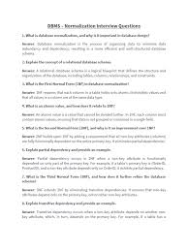

explain the forms of the 1NF

While "First Normal Form" (1NF) is a single, foundational concept, it is defined by a set of criteria or rules that a database table must satisfy. Thinking of these as the "forms" of 1NF is a way to understand its specific requirements. A table that adheres to these rules is structured logically and avoids a variety of data-related problems.

A table is in 1NF if it meets all of the following conditions:

1. Atomicity of column values

This is the most critical rule of 1NF. Each cell in the table must contain a single, indivisible (atomic) value.

* **What this eliminates:** Multi-valued attributes, where a single cell holds a list or a set of values.
* **Example of what to fix:** A column for a customer's phone numbers might look like "555-1234, 555-5678." This violates 1NF.
* **How to fix it:** The multi-valued column must be broken out so that each individual value is in its own row. For example, the customer's second phone number would be in a new row, and both rows would share the same customer ID.

2. Elimination of repeating groups

A repeating group occurs when a table has multiple columns for similar data, such as Class1, Class2, and Class3.

* **What this eliminates:** The need to add new columns to a table as the data changes, which requires table modifications and creates inefficient use of space.
* **Example of what to fix:** A table with columns (Ordered, Product1, Product2, Product3) contains a repeating group of product information.
* **How to fix it:** The repeating group must be moved into a separate table. The original table is then linked to the new table with a primary key-foreign key relationship.

3. Unique records

Every row in the table must be unique. A primary key is typically used to enforce this rule.

* **What this eliminates:** Duplicate rows, which can cause inconsistencies when updating or deleting data.
* **How to ensure it:** Designate a primary key, which is a column or set of columns that uniquely identifies each record in the table.

4. Uniformity of data types

Each column should store values of a single, consistent data type across all rows.

* **What this eliminates:** Inconsistent data storage within a single attribute.
* **Example:** A column named date should not contain a mix of dates and text strings.

5. Order independence

The order of rows and columns should not have any intrinsic meaning.

* **What this eliminates:** Dependence on a specific order, which makes the data more flexible and reliable.
* **Example:** A table's functionality should not rely on the first row containing the oldest record. The relational model dictates that rows are an unordered set.

AI responses may include mistakes.

Thank you

Your feedback helps Google improve. See our [Privacy Policy](https://policies.google.com/privacy?hl=en).

Share more feedbackReport a problemClose

undefined





19 sites

* undefined





19 sites

* First Normal Form (1NF) - GeeksforGeeks

8 Sept 2025 — First Normal Form (1NF) * All the attributes (columns) contain only atomic (indivisible) values. * Each column conta...

favicon

GeeksforGeeks



* First Normal Form (1NF) - GeeksforGeeks

8 Sept 2025 — First Normal Form (1NF) * All the attributes (columns) contain only atomic (indivisible) values. * Each column conta...

favicon

GeeksforGeeks



* Database Normalization: 1NF, 2NF, 3NF & BCNF Examples

26 Jul 2025 — First Normal Form (1NF) First Normal Form (1NF) is the initial stage in the process of database normalization. It en...



DigitalOcean



* Database normalization description - Microsoft 365 Apps

24 Jun 2025 — First normal form * Eliminate repeating groups in individual tables. * Create a separate table for each set of relat...



Microsoft Learn

* Understanding First Normal Form (1NF) in DBMS | by Amirnagy

8 Jun 2025 — 🔎 What Is First Normal Form (1NF)? 1NF ensures that your data is organized in a way that eliminates redundancy at th...



Medium



* Normalization in SQL DBMS: 1NF, 2NF, 3NF, and BCNF Examples

25 Jul 2023 — The first normal form is the first step in the process. For a database design to be in first normal form, or 1NF, ea...



PopSQL

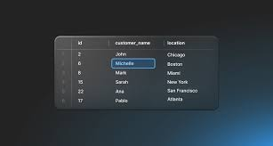

* First Normal Form (1NF) - Kev's Robots

It defines the basic requirements for organizing data in a relational database. ... First Normal Form (1NF) is a fundamental conce...



Kev's Robots



* Understanding First Normal Form (1NF) in DBMS | by Amirnagy

8 Jun 2025 — 🔎 What Is First Normal Form (1NF)? 1NF ensures that your data is organized in a way that eliminates redundancy at th...



Medium



* Data Normalization: What It Is & How to Normalize It

9 Jun 2025 — For example, consider a Contacts table where the PhoneNumbers field contains "555-1234, 555-5678, 555-9012" as a comm...



New Relic



* Normalization in SQL DBMS: 1NF, 2NF, 3NF, and BCNF Examples

25 Jul 2023 — The first normal form is the first step in the process. For a database design to be in first normal form, or 1NF, ea...



PopSQL



* What is Normalization in DBMS (SQL)? A Comprehensive Guide to 1NF, 2NF, and 3NF Examples - SQL Knowledge Center

11 Jul 2023 — This form is all about ensuring that your database schema is designed with efficiency and reliability in mind. It's ...

favicon

SQL Easy



* Database Normalization in DBMS: Types, Forms & Examples

24 Nov 2024 — Below are the common types of normal forms in DBMS. * First Normal Form (1NF) The first normal form in DBMS requires...

favicon

Talent500

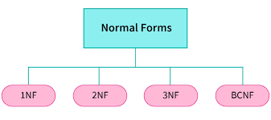

* Database Design: Normalization - Javier Feliu

14 Aug 2020 — Repeating groups A table has repeating groups when several of its columns store the same type of value. In the last ...



LinkedIn



* Data Modelling Fundamentals: Normalisation, 3NF and Dimensional Modelling

10 Jan 2025 — There should be no repeating groups in a table. If any repeating groups exist, they should be moved into a separate ...



Pipeline To Insights

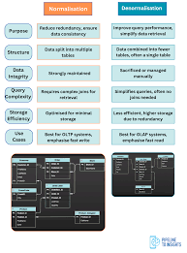

* Understanding First Normal Form in DBMS

25 Mar 2025 — Converting the Table into 1NF-Compliant Form To convert this table into First Normal Form (1NF), we must ensure that...



Pickl.AI

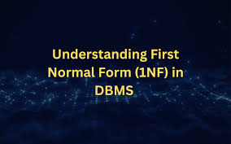

* Database Systems - Structural Rules and Data Independence

15 Sept 2021 — If data is duplicated, then it is easy to miss one of the duplicates when updating, leading to different copies hav...



YouTube



* Untitled

24 Oct 2008 — 2. A primary key has been defined, which uniquely identifies each row in the relation. Remove Repeating Groups As yo...



University of Nebraska–Lincoln

* 3 Rela onal Database A relational database consists of a collection of tables, each of which assigned a unique name. The table

So, how do databases keep all of these records straight? It's through the use of keys. The first type of key we'll discuss is the ...

favicon

University of Anbar

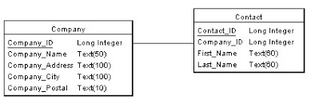

* Hospital Normalization Key | PDF | Medicine | Health Care

When moving from an Unnormalized table to 1NF you need to take out repeating groups. One approach is to fill in empty cells. A sec...

favicon

Scribd



* Relationships: Your Key to Data Integrity

Without a unique identifier, it becomes programmatically impossi- ble to uniquely address a row. You guarantee uniqueness in a tab...



www.pearsonhighered.com

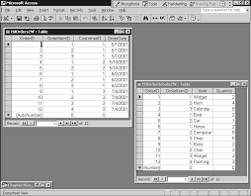

* Relational model - Wikipedia

The current ISO SQL standard doesn't mention the relational model or use relational terms or concepts. According to the relational...



Wikipedia

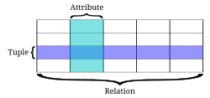

* Normalisation and its Types (1NF, 2NF, 3NF) - Tutorial

Welcome to takeUforward Reduces data duplication: Storing each piece of data only once minimizes inconsistencies and makes data ea...



takeUforward

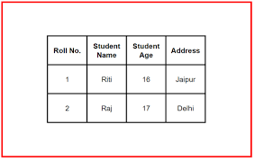

undefined



19 sites

* First Normal Form (1NF) – Geeks for Geeks

8 Sept 2025 — First Normal Form (1NF) * All the attributes (columns) contain only atomic (indivisible) values. * Each column contra...

favicon

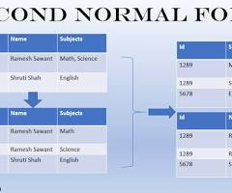

* Database Normalization: 1NF, 2NF, 3NF & BCNF Examples

26 Jul 2025 — First Normal Form (1NF) First Normal Form (1NF) is the initial stage in the process of database normalization. It ends...

Microsoft Learn

Show all

explain the second normal form

For a database table to be in the Second Normal Form (2NF), it must satisfy two conditions:

1. It must already be in First Normal Form (1NF).
2. It must not contain any **partial dependencies**. This means all non-key attributes must be fully functionally dependent on the entire primary key, not just a part of it.

What is a partial dependency?

A partial dependency is a functional dependency where a non-key attribute is determined by only a subset of a composite (multi-attribute) primary key.

This problem can only occur in tables with a composite primary key, because if a primary key consists of a single attribute, any non-key attribute is automatically fully dependent on the entire key.

Example of converting from 1NF to 2NF

Imagine a table from an online bookstore that tracks book orders.

**Initial Table in 1NF**

This Order Details table is in 1NF because all its column values are atomic (single-valued). However, it is not in 2NF.

|  |  |  |  |  |
| --- | --- | --- | --- | --- |
| **Ordered (PK)** | **Productid (PK)** | **ProductName** | **Product Price** | **Quantity** |
| 1001 | A01 | "The Art of Data" | 29.99 | 1 |
| 1001 | A02 | "SQL for Beginners" | 39.99 | 2 |
| 1002 | A01 | "The Art of Data" | 29.99 | 1 |

* **Primary Key:** The composite key is {Ordered, Productid} because a single order can contain multiple products.
* **Problem:** The ProductName and Product Price non-key attributes depend only on Productid, not the entire composite key. This is a partial dependency.
* **Anomalies:**
  + **Update Anomaly:** If you need to change the price of "The Art of Data," you must update multiple rows, creating an opportunity for inconsistent data.
  + **Insertion Anomaly:** You cannot add a new product and its price to the table until it is included in an order.

**Tables in 2NF**

To normalize the table to 2NF, you must remove the partial dependency by splitting the original table into two new tables.

**Table: Order Details**  
This new table keeps the attributes that are fully dependent on the composite key.

|  |  |  |
| --- | --- | --- |
| **Ordered (PK)** | **Productid (PK)** | **Quantity** |
| 1001 | A01 | 1 |
| 1001 | A02 | 2 |
| 1002 | A01 | 1 |

**Table: Products**  
This table contains the attributes that were partially dependent on the original key, with the part of the key they depended on becoming the new table's primary key.

|  |  |  |
| --- | --- | --- |
| **Productid (PK)** | **ProductName** | **Product Price** |
| A01 | "The Art of Data" | 29.99 |
| A02 | "SQL for Beginners" | 39.99 |

**Resulting benefits:**

* **Reduced Redundancy:** The product name and price are now stored only once in the Products table.
* **Improved Consistency:** Updates to a product's price only need to be made in a single place.
* **Resolved Anomalies:** You can now add or delete product information independently of any orders.

AI responses may include mistakes.

Thank you

Your feedback helps Google improve. See our [Privacy Policy](https://policies.google.com/privacy?hl=en).

Share more feedbackReport a problemClose



undefined



24 sites

* 

undefined



24 sites

* Database Normalization: 1NF, 2NF, 3NF & BCNF Examples | DigitalOcean

25 Jul 2025 — This makes querying, updating, and maintaining data more efficient and reliable, and it helps avoid redundancy right...



DigitalOcean



* Second Normal Form (2NF) - GeeksforGeeks

11 Jul 2025 — Second Normal Form (2NF) ... Second Normal Form (2NF) is based on the concept of fully functional dependency. It is ...

favicon

GeeksforGeeks



* Partial Dependency in DBMS - GeeksforGeeks

22 Jul 2025 — Partial Dependency in DBMS * Databases are structured to handle cases where some data relies on only part of a key, ...

favicon

GeeksforGeeks

* Second Normal Form (2NF) - Kev's Robots

Further organize and eliminate redundancy in a relational database. ... Second Normal Form (2NF) is a concept in database normaliz...



Kev's Robots



* Describe the second normal form with an example - Filo

30 Jan 2025 — Describe the second normal form with an example * Concepts: Database normalization, Second normal form. * Explanatio...



Filo

* Understanding Partial Dependency in DBMS - Testbook

Understanding Partial Dependency in DBMS - Testbook. ... When a relation in a database has a functional dependency (FD) that still...

favicon

Testbook

* Second Normal Form in DBMS - Definition, Uses, Rules, and ...

Second Normal Form in DBMS - Definition, Uses, Rules, and Examples. ... The Second Normal Form (2NF) is a crucial concept in Datab...

favicon

Testbook

* Second Normal Form (2NF) in DBMS - Study Glance

Example for Second Normal Form. ... Here, a combination of `Student_ID` and `Course_ID` can be considered as a primary key because...



Study Glance

* Normalisation — Isaac Computer Science

The rule for 2NF is no partial dependencies. Are there any partial dependencies? Partial dependencies arise where a table has a co...



Isaac Computer Science



* Normalize vs. Denormalize Database: Key Differences - Database Guide

To achieve 2NF, the table must first be in 1NF, and all nonkey attributes must be fully dependent on the entire primary key. This ...



SolarWinds

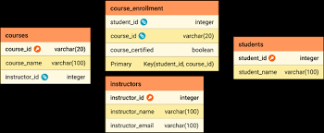

* How to Normalize a Database Into 2NF and 3NF (With Examples)

1 Nov 2021 — Normalization to 2NF * We'll work with a table named Courses1 , which contains information about courses offered at a...



Vertabelo Database Modeler



* Relational Databases > Designing/creating Relational Databases > First Normal Form (1NF)

First Normal Form (1NF) Only atomic values: this means there should be one value in each column, per row No repeating groups: this...

favicon

Cornell Virtual Workshop

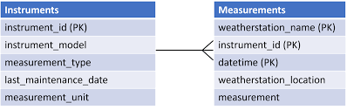

* How the Third Normal Form Improves Data Normalization

20 Nov 2023 — To bring the table into 3NF, it needs to be split into three smaller tables with one primary key and no transitive d...



LinkedIn



* The Three Normal Forms in Database and Why You Might Ignore Them

18 Apr 2025 — The Three Normal Forms in Database and Why You Might Ignore Them * 1. First Normal Form (1NF: Ensuring Atomicity in ...



Medium

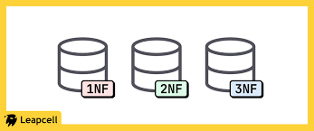

* Data Modelling For Beginners

Orders Table to Order Details Table: A one-to-many relationship (1 to *), as one order can include multiple products.



The Data School

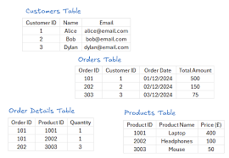

* Master Data Normalization: Boost Accuracy & Efficiency!

26 Mar 2025 — Practical Examples of 2NF Here, Product Name depends only on ProductID, not on the whole composite key (OrderID, Pro...



Data Science Dojo



* Normal Forms in DBMS - GeeksforGeeks

19 Sept 2025 — Think of them as layers of cleanliness for your tables: the deeper you go, the fewer redundancy and integrity probl...

favicon

GeeksforGeeks



* Data Normalization: What It Is & How to Normalize It

9 Jun 2025 — Apply 2NF: Ensure non-key attributes depend on the entire primary key. For example, in an OrderDetails table with Ord...



New Relic



* Second Normal Form (2NF) - Database Normalization - 1Keydata

2nd Normal Form Example ... This table has a composite primary key [Customer ID, Store ID]. The non-key attribute is [Purchase Loc...

favicon

1Keydata

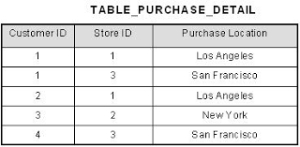

* Data Models: Physical Data Model vs. Logical Data Model

6 Mar 2024 — The same applies to the Product table — information about a specific product is stored only once, but this product ca...



GoodData

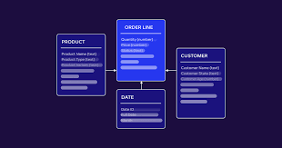

* How to Normalize Data (2025 Guide)

1 Jun 2025 — Reduced Redundancy: Each data point is stored only once, eliminating unnecessary repetition across tables.



www.knack.com



* Mastering Database Design: Normalization Explained

3 Nov 2024 — The Price is stored only once in the Products table, and the Orders table simply links to it. This reduces redundancy...



luminousmen

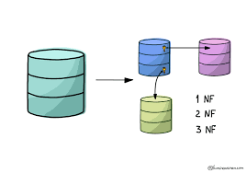

* Data Normalisation Guide: Improve Database Design& Integrity

11 Jun 2025 — With a normalised structure, updating a product's information required changing only one record, ensuring consistenc...



Valorem Reply



* AUD CPA Exam: Understanding the Components of a Relational Database – SuperfastCPA CPA Review

Example: In a table where OrderID and ProductID form a composite primary key, if the ProductName attribute depends only on Product...



SuperfastCPA





24 sites

* Database Normalization: 1NF, 2NF, 3NF & BCNF Examples | Digital Ocean

25 Jul 2025 — This makes querying, updating, and maintaining data more efficient and reliable, and it helps avoid redundancy right...

* Second Normal Form (2NF) -

11 Jul 2025 — Second Normal Form (2NF) ... Second Normal Form (2NF) is based on the concept of fully functional dependency. It is ...

favicon



* Partial Dependency in DBMS -

22 Jul 2025 — Partial Dependency in DBMS * Databases are structured to handle cases where some data relies on only part of a key, ...

favicon

Show all

use tables to explain the second normal form

**Thinking**

**Kicking off** 6 searches

**Looking at** 61 sites

**Putting it all together**

Before 2NF: A table with partial dependency

Consider a table named Enrolments that records information about students taking certain courses.

* **Primary Key:** (Student, Coursed)
* **Non-Key Attributes:** Student Name, Course Name, and Instructor

This table is in First Normal Form (1NF), because each cell contains a single value and there are no repeating groups. However, it is not in 2NF due to a **partial dependency**. The Student Name attribute depends only on Student (part of the composite primary key), and Course Name and Instructor depend only on Coursed (the other part of the composite key).

**Enrolments Table (Not in 2NF)**

|  |  |  |  |  |
| --- | --- | --- | --- | --- |
| **Student (PK)** | **coursed (PK)** | **Student Name** | **Course Name** | **Instructor** |
| 1 | 101 | Alice | Intro to DBMS | Prof. Smith |
| 1 | 102 | Alice | Data Structures | Prof. Jones |
| 2 | 101 | Bob | Intro to DBMS | Prof. Smith |
| 3 | 103 | Charlie | Algorithms | Prof. Davis |

**Problems with this table:**

* **Data Redundancy:** Alice's name is repeated for every course she takes.
* **Update Anomaly:** If Alice changes her name, it must be updated in multiple places. Failure to update all occurrences would lead to inconsistent data.
* **Insertion Anomaly:** You cannot add a new course with its instructor until a student enrols in it.
* **Deletion Anomaly:** Deleting the last student from a course (e.g., Charlie from "Algorithms") would also delete all information about that course.

After 2NF: Decomposed tables

To convert the enrolments table into 2NF, you must eliminate the partial dependencies by decomposing it into smaller, related tables.

**1. Students Table**  
This table contains information about students, with Student as its primary key.

* **Functional Dependency:** student



→right arrow

→

Student Name

|  |  |
| --- | --- |
| **student (PK)** | **Student Name** |
| 1 | Alice |
| 2 | Bob |
| 3 | Charlie |

**2. Courses Table**  
This table contains information about courses, with coursed as its primary key.

* **Functional Dependency:** coursed



→right arrow

→

Course Name, Instructor

|  |  |  |
| --- | --- | --- |
| **coursed (PK)** | **Course Name** | **Instructor** |
| 101 | Intro to DBMS | Prof. Smith |
| 102 | Data Structures | Prof. Jones |
| 103 | Algorithms | Prof. Davis |

**3. enrolments Table (Link Table)**  
This table links students to courses using the composite primary key (student, coursed). All attributes are fully dependent on this key.

* **Functional Dependency:** (student, coursed)



→right arrow

→

(no non-key attributes)

|  |  |
| --- | --- |
| **student (FK, PK)** | **coursed (FK, PK)** |
| 1 | 101 |
| 1 | 102 |
| 2 | 101 |
| 3 | 103 |

**Benefits of the 2NF structure:**

* **Reduced Redundancy:** Student and course information is no longer repeated.
* **Improved Consistency:** An update to a student's name only requires a single change in the Students table.
* **Eliminated Anomalies:** You can add a new course and its instructor to the Courses table without it being tied to a student. Similarly, deleting a student's enrolment no longer deletes course information.